SOA:Save our animals

PAT: Ontwerpsdokument

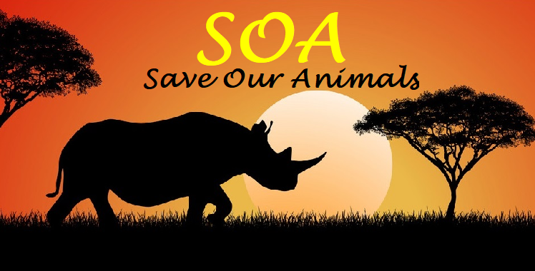

**AFRICA**

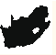**-Logo**

**DIAN NAUDE 18 October 2021**

**Table of contents**

1 TASK 1 4

1.1 A: TAAKDEFINISIE 4

1.2 B: User Requirements 5

2 Task 2: Databasis-Ontwerp 6

2.1 Relationship 6

2.2 tblAnimals 7

2.2.1 Design View 7

2.3 tblClient 10

2.3.1 Design View 10

2.4 tblProducts 13

2.4.1 Design View 14

2.5 tblService 16

2.5.1 Design View 17

2.6 tblTransaction 19

2.6.1 Design View 19

2.7 tblAnimalDonations 21

2.7.1 DesignView 21

2.8 tblPurchaseRecord 23

3 Task3 26

3.1 Classes and objects 26

3.2 Text File’s B 27

3.3 Arrays C 27

3.4 Advanced Features 28

4 Task 4 29

4.1 A Navigation 29

4.2 B GUI 31

4.2.1 Login 31

4.2.2 Admin 34

4.2.3 User 42

5 IPO tables 48

Input, Processing Validation Output 48

**List of Figures**

Figure 1 CaseDiagram 5

Figure 2 Relationships 6

Figure 3 tblAnimals 7

Figure 5 tblClients 10

Figure 6 tblClients Design View 10

Figure 10 tblProducts 13

Figure 11 tblProducts Design View 14

Figure 12 Navigation Flow diagram 28

# TASK 1

## A: TAAKDEFINISIE

IT PAT 2023 –Dian Naude

**SOA**

SOA short for Save Our Animals is an international organisation that cares for animals all over the world. We at SOA have identified a worldwide problem. Animals that are being killed unjustly like the rhinoceros and animals that lose their homes, like the Giant Panda. There are so many examples of these kinds of problems. We have to make a difference!

SOA has decided to create a retail website where products and services can be sold. We have a wide range of game drives animal exhibitions, wild life sanctuaries all over the world that can be visited. SOA will have different interfaces for each country, but the first version will be for South Africa only. When a service or product is bought a percentage of the money will go to the protection of a certain endangered animal, it will be up to the customer to decide where his/her money goes. Money can also be donated directly without a purchase.

The Website offers companies or individuals to buy products for example a lion hat or African woodwork and many many more. It also provides a service which can be various things from zip lining through bird sanctuaries to walking with elephants!

We want to save the wildlife of our world and prevent extinction events.

We are SOA and we strive to save!

## B: User Requirements

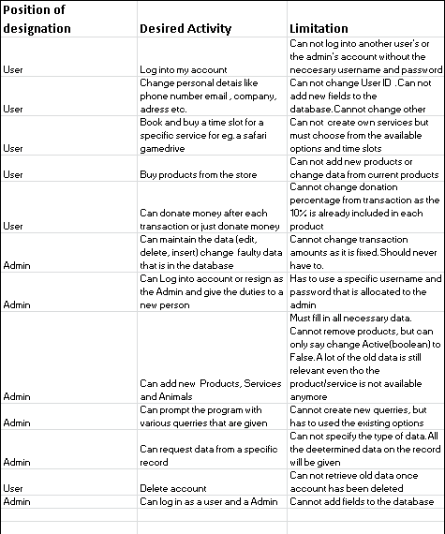

Figure CaseDiagram

# Task 2: Databasis-Ontwerp

## Relationship

AnimalID (from tblAnimals) has a one too many relationship with AnimalID(from tblAnimalDonations).TransactionID from (tblTransaction) has a one too many relationship with TransactionID(from tblAnimalDonations). ClientID (from tblClient) has a one to many relationship with ClientID (from tblTransactions). ProductID (from tblProducts) has a one to many relationship with ProductID (from tblPurchaseRecord). ServiceID (from tblService) has a one to many relationship with ServiceID (from tblPurchaserecord).TransactionID(from tblTransaction) has a one to many relationship with transactionID(from tblPurchaseRecord) .

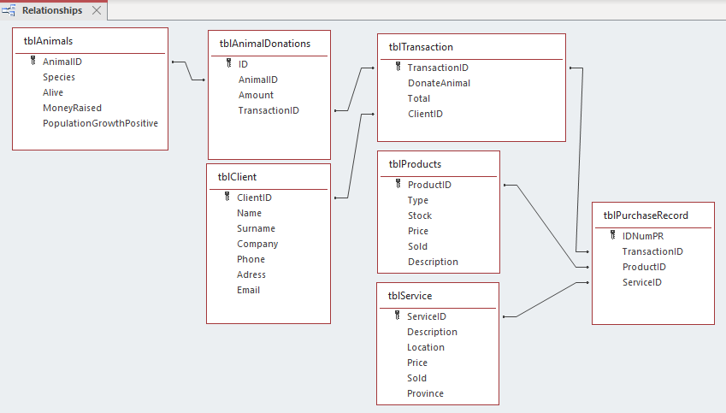

Figure Relationships

## tblAnimals

All the Animals that are endangerd are listed in this table with all the rlevant data concerning them

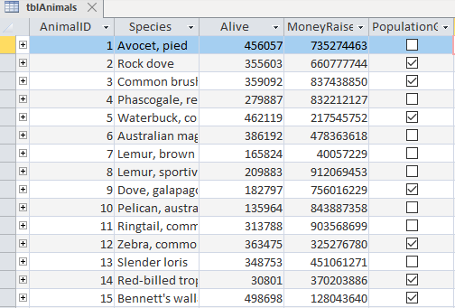

Figure tblAnimals

### Design View

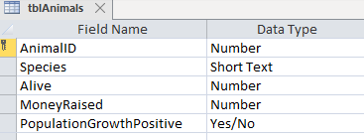

#### AnimalID

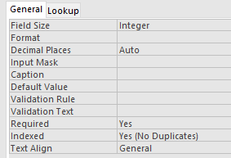

#### Species

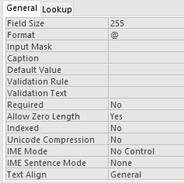

#### Alive

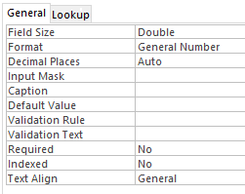

#### MoneyRaised

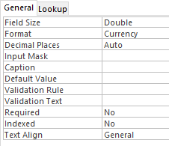

#### PopulationGrowthPositive

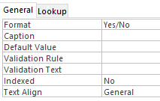

## tblClient

All the Clients of SOA are listed here as well as their respected details.

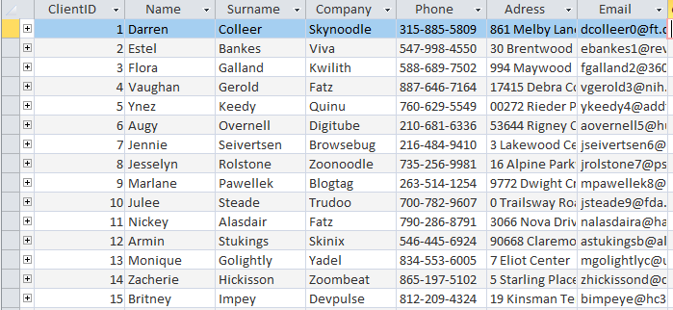

Figure tblClients

### Design View

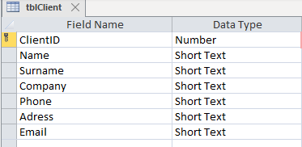

Figure tblClients Design View

#### ClientID

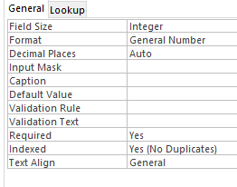

#### Name

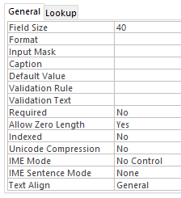

#### Surname



#### Company

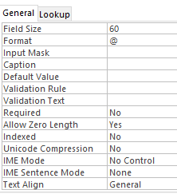

#### Phone

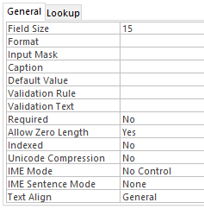

#### Adress

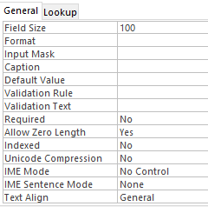

#### Email

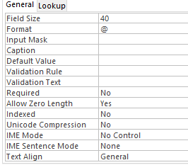

## tblProducts

All the data of the specific product is stored in the table as well as the amount available and the amount sold

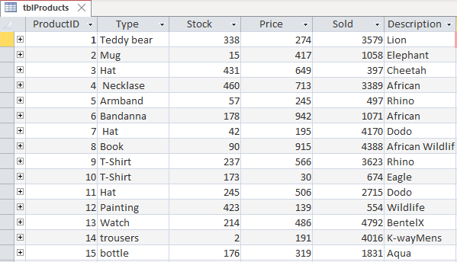

Figure tblProducts

### Design View

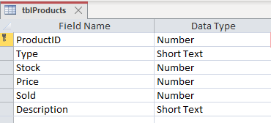

Figure tblProducts Design View

#### ProductID

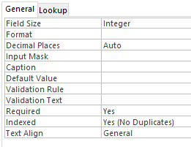

#### Type

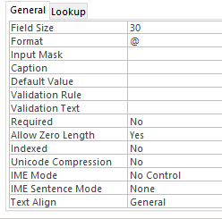

#### Stock

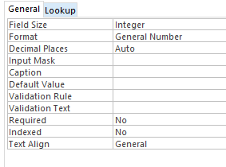

#### Price



#### Sold

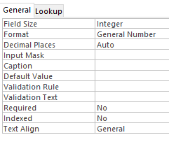

#### Description

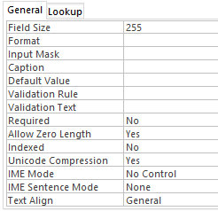

## tblService

This table stores all the data that is relevant to the specific service that the client may purchase as well as how many of the specific service has been sold.

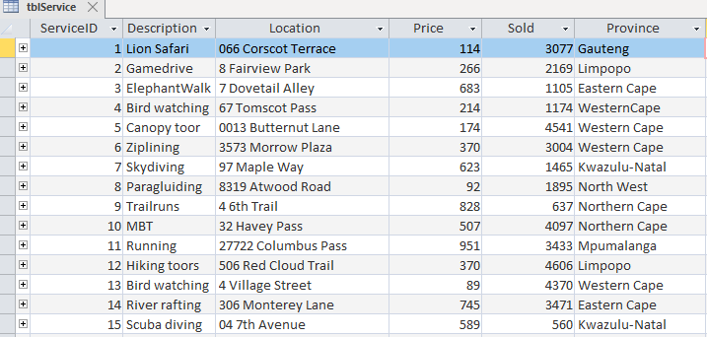

### Design View

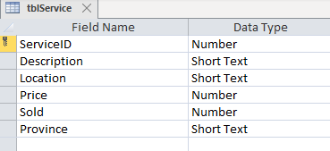

#### ServiceID

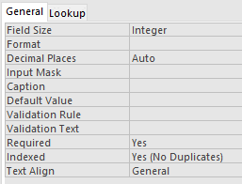

#### Description

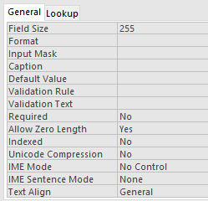

#### Location

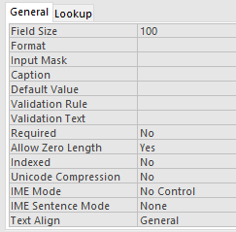

#### Price

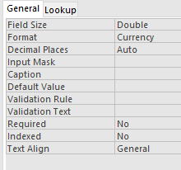

#### Sold

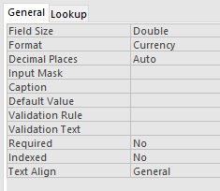

#### Province

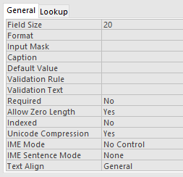

## tblTransaction

This table stores all the transactions that has taken place.We can see who spent the money, How much did they spent and the amount that went to Donations for certain species.

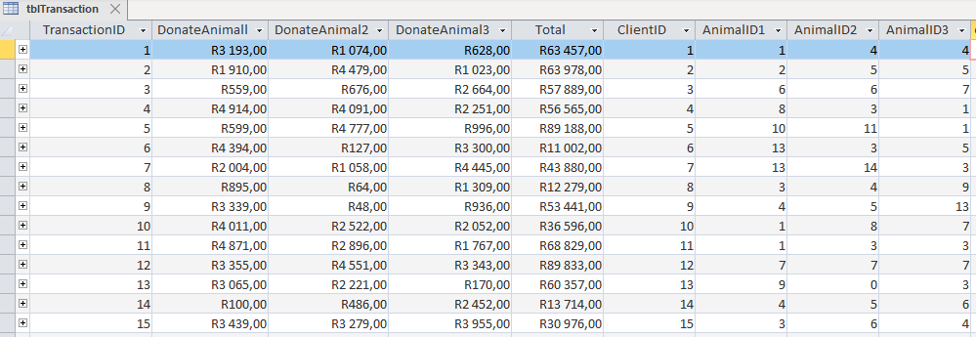

### Design View

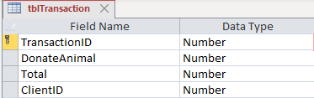

#### TransactionID

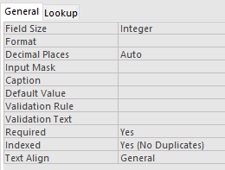

#### DonateAnimal

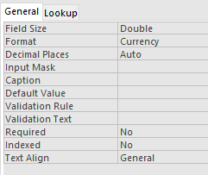

#### Total



#### ClientID

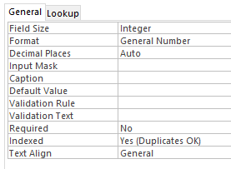

## tblAnimalDonations

This Table stores how much money of each transaction goes to each Animal. If it comes through a direct donation or via a purchase at the store(SOA) it wil be recorded

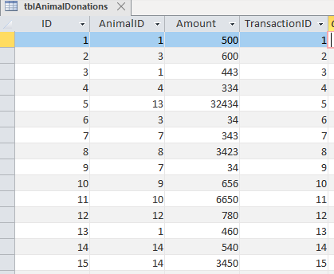

### DesignView

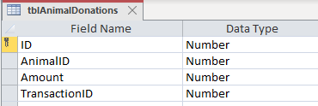

#### ID

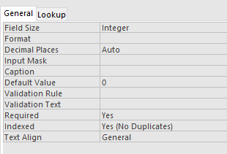

#### AnimalID

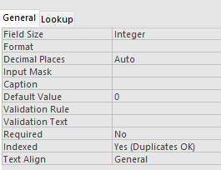

#### Amount

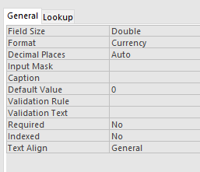

#### TransactionID



## tblPurchaseRecord

This table stores all the products that are bought from a specific Transaction.Dependant on how many of the specific product or service was bought is how many times the Transaction will be listed in this table(TransactionID) If a product was bought and not a service it will be indicated by a -1 and vice versa

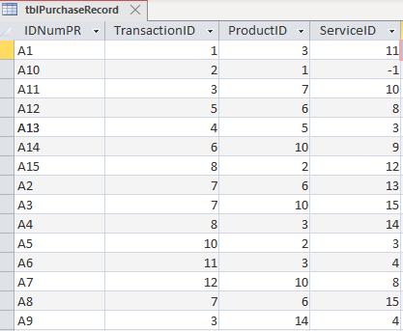

#### IDNumPR

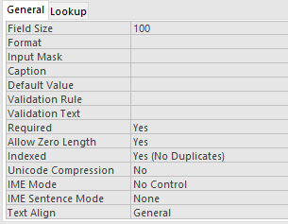

#### TransactionID

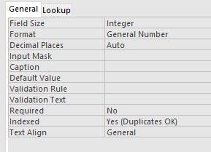

#### ProductID

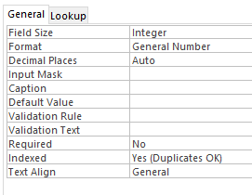

#### ServiceID



# Task3

Variables will be used in various ways real, string, integer, Boolean etc. to calculate and finish the desired processes. Global variables will be used to identify the current logged in user from the Login form and in the User form. Thus giving a global identity of the user through the program.

## Classes and objects

Each client’s data will be defined in an object variable, which will be read from a text file. Data that will not be found in the Database will be stored and be retrieved into an object variable. For example last log in date, time spent in the online store, etc. This data will be accessible to the Admin and to no one else.

#### Client Class Diagram

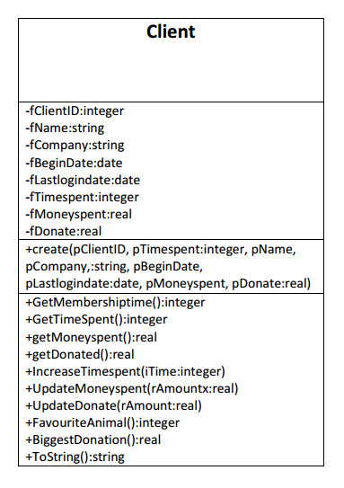

## Text File’s B

Text Files are used to store the username and password of each client giving him/her access to their account via their username and passwords. The current Admins details are stored in a Text File. When and Admin resigns as the Admin the old Admins data is removed and the new Admins data is added. When a client wants to delete his/her account their username and password is deleted from the Text file. Text files will also be used to store Class data

Text Files are used to store the contents of the basket. When you select an item at the store the program automatically adds it to a basket which is visible to the client. The contents of this basket is stored in a textfile for the specific client.If the client decides not to go through with the purchase the contentss of the basket is still there and safely stored in the textfile.Thus if the client returns after a few days the contents of the basket are still in tacked. The client can add, increase, decrease and remove items from the basket where it will then also be removed from the textfile.

Data is collected from each client to create a summary of his/her behaviour on the program this data is also stored in a textfile. Changes brougt from their behaviour is stored in the textfile and later read from the textfile to display their behaviour to the Admin

## Arrays C

Arrays will be used to store the users Password and Username. Two corresponding Arrays will be used where one contains the Username and the other contains the password. New Users can be added with their new usernames and their given password. When Logging on the program will check if the Username Corresponds with the Password if it does the User Form will be shown of that specific user. When the Admin Logs in the Admin Username will be checked to identify the Admin and check if the given password corresponds with the Admins Password. Only then will the Admin form show and the Login form hide .

In the SOA program you can donate money to a specific Animal. A Dynamic panel with components on is created where you can pay your donations to the respected animals. You have the liberty of adding each donation you make. When you are satisfied you can finish the payment and click on the given button. Each Donation you add is stored in 2 parallel dynamic arrays. The one array contains the name of the Animal you are donating the money to and the other array contains the amount you are donating to the specific animal. When adding the data to the array the length of the array is changed using the setlength procedure.When and only when the “finish payment button” is selected the data from the arrays will be used and added to the database.The arrays will be cleared with the clearArray procedure that was written and you are able to make another donation or buy a product and/or service.

## Advanced Features

The use of the object TOTPTwillo which makes use of the service provided by Twillo. It enables the program to send messages to the user. It is used to sent Notifications OTPs etc. The code makes use of Http and URLs and various other components to access twillo online.It access my account with code and then the messages are sent from a twillo registerd number.

The use of Dialogue boxes which has html code within it. This enables the user to access hyperlinks from the program and watch a video about endangered species

Scources: <http://delphiprogrammingdiary.blogspot.com/2019/04/ttaskdialog-custom-dialog-in-delphi.html?m=1>

Scources: <https://www.twilio.com/docs/sms/tutorials/how-to-send-sms-messages-delphi>

# Task 4

## A Navigation

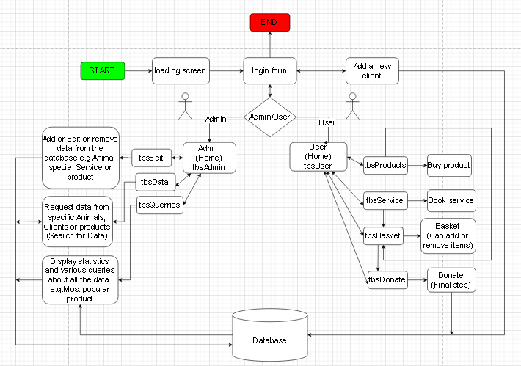

Figure Navigation Flow diagram

## B GUI

### Login

#### tbsLogin

Client logs into account with his/her username and password.Or if it is a new client he/she can sign up.

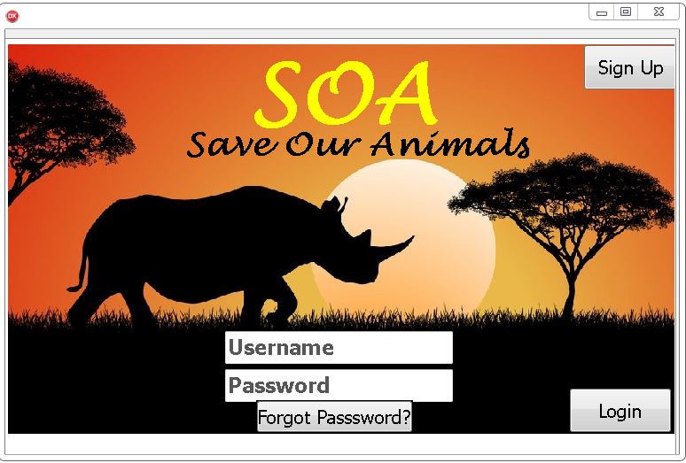

#### tbsAddClient

Client signs up to become a registered client.

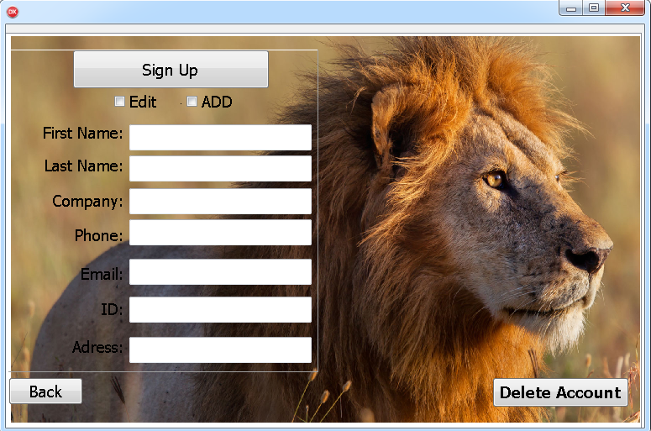

Components

type

TfrmLogin = class(TForm)

PageControlLogin: TPageControl;

tbsLogin: TTabSheet;

tbsAddClient: TTabSheet;

imgLogin: TImage;

btnLogin: TButton;

edtPass: TEdit;

edtUser: TEdit;

pnlAddPlayer: TPanel;

Label4: TLabel;

Label5: TLabel;

Label6: TLabel;

Label7: TLabel;

Label8: TLabel;

Label9: TLabel;

btnAdd: TButton;

edtNameL: TEdit;

EdtLastNameL: TEdit;

edtCom: TEdit;

edtPhoneL: TEdit;

edtEmailL: TEdit;

edtIDL: TEdit;

btnSignUp: TButton;

btnForgot: TButton;

btnBack: TButton;

imgLion: TImage;

Label1: TLabel;

Label2: TLabel;

edtAdress: TEdit;

Label3: TLabel;

chkADD: TCheckBox;

chkEDIT: TCheckBox;

CheckBox1: TCheckBox;

btnDeleteA: TButton;

### Admin

#### tbsAdmin

Admin form where Queries Editing or Data retrieval can be performed

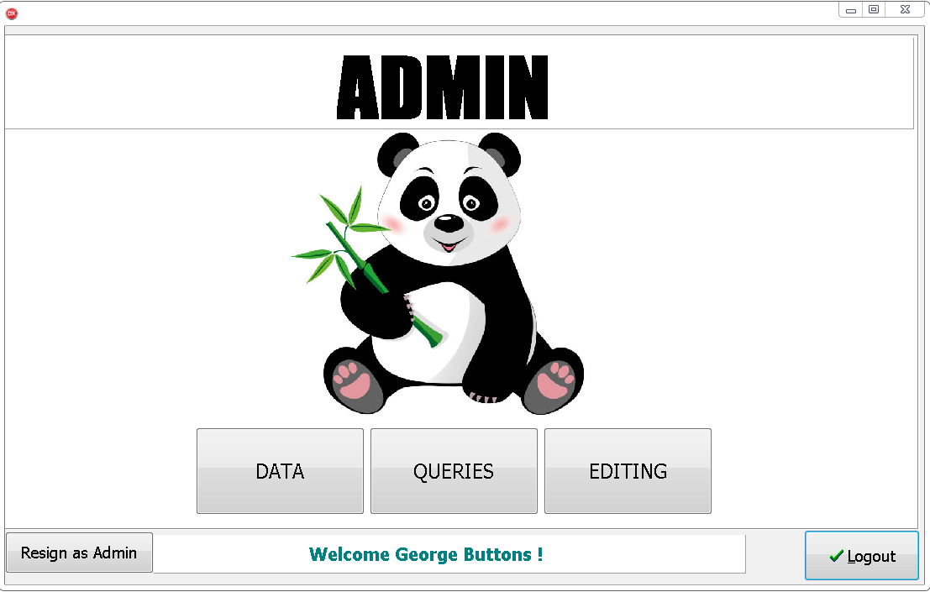

#### tbsData

Data is retrieved from a specific Animal Client Product or Service

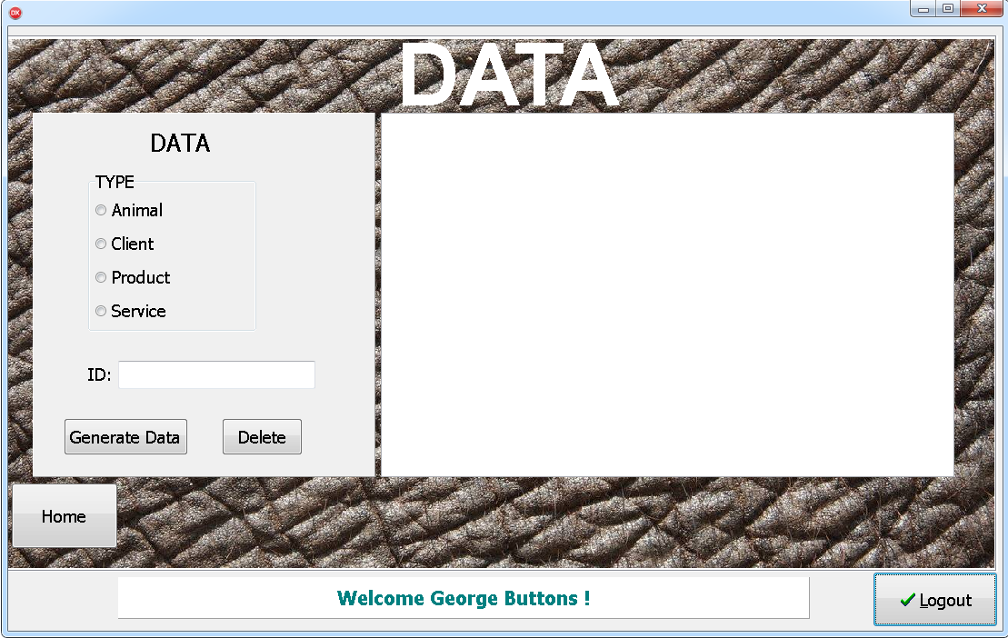

#### tbsQuerries

Various queries are given and outputs are shown in the DBgrid

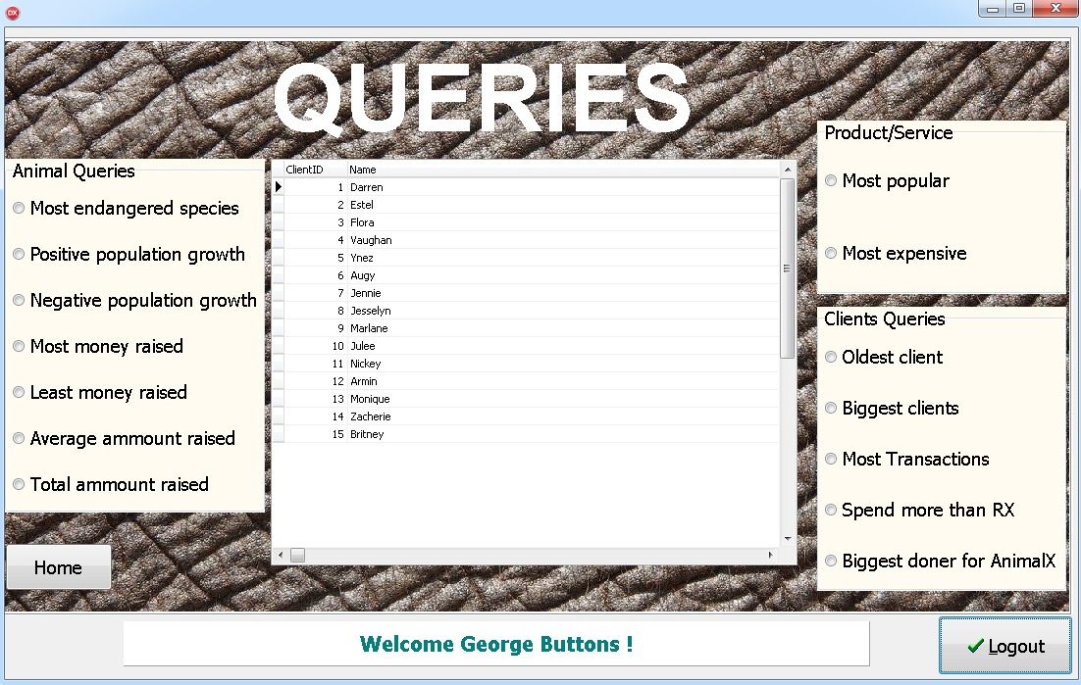

#### tbsEditing

Edit various identities or add new ones

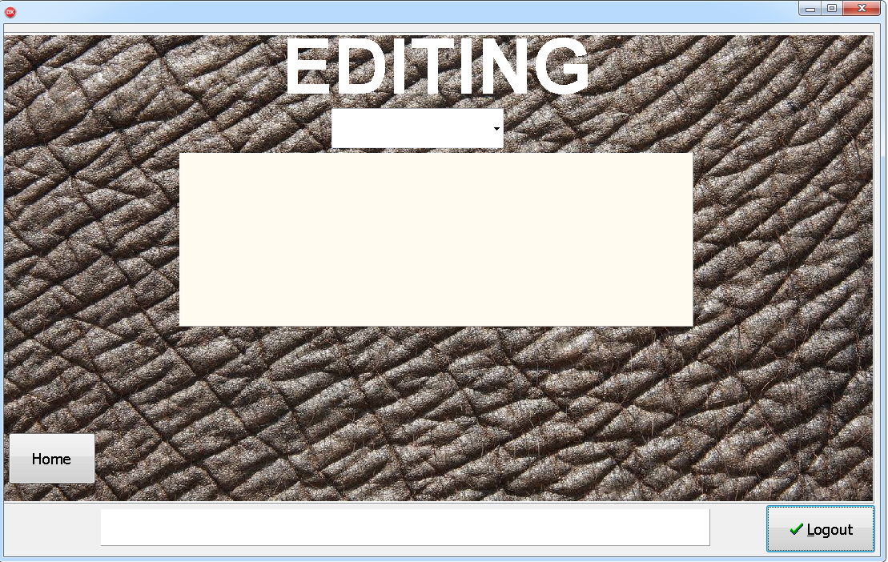

#### Edit Animals

Edit an existing animal or add a new animal

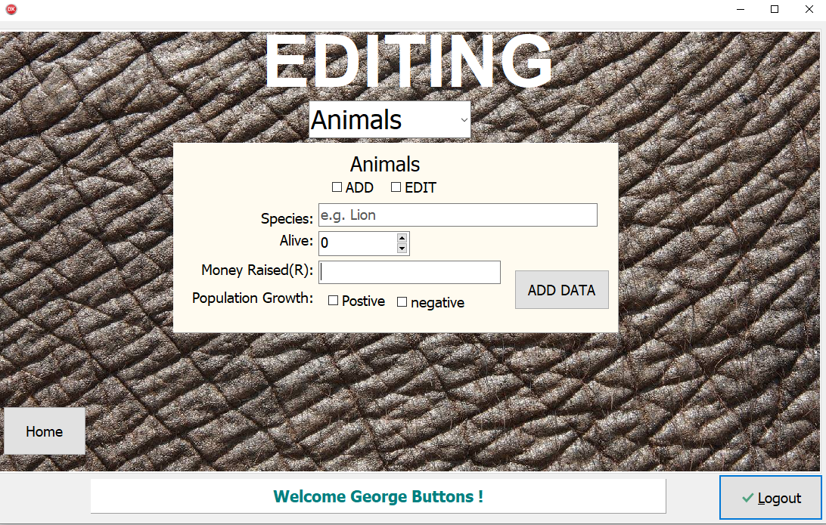

#### Edit Service

Edit an existing service or add a new service

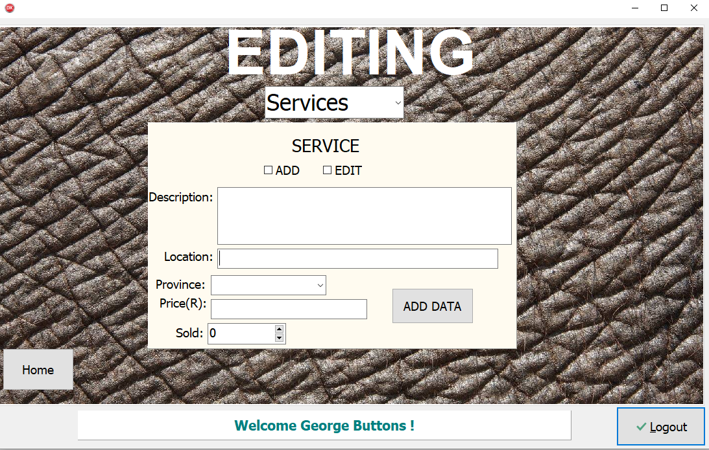

#### Edit Product

Edit an existing product or add a new product

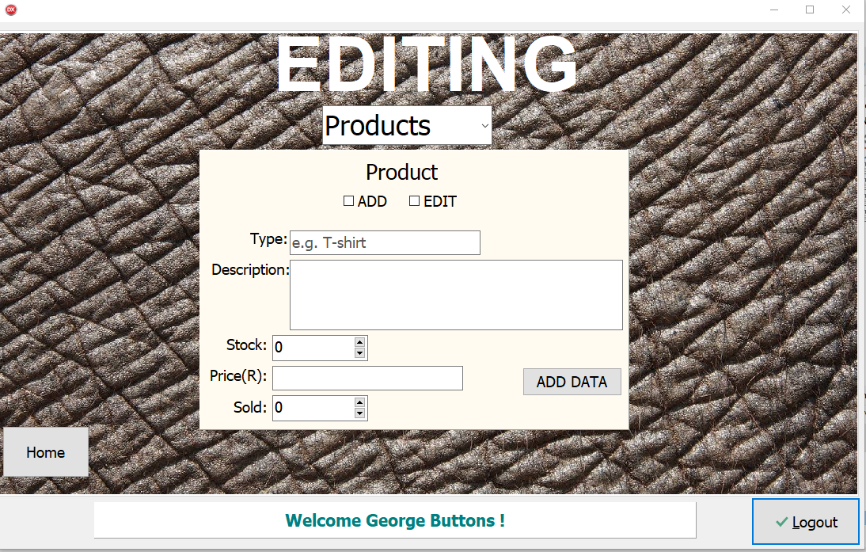

Components

type

TfrmAdmin = class(TForm)

lblQuerriesA: TLabel;

bmbLogoutAdmin: TBitBtn;

PageControlAdmin: TPageControl;

tbsAdmin: TTabSheet;

tbsData: TTabSheet;

tbsEditing: TTabSheet;

tbsQuerries: TTabSheet;

btnData: TButton;

btnQuerries: TButton;

btnEditing: TButton;

btnHome3: TButton;

btnHome2: TButton;

btnHome1: TButton;

pnlNameNumA: TPanel;

dbgQuerries: TDBGrid;

rgpAnimalX: TRadioGroup;

rgpPS: TRadioGroup;

pnlProduct: TPanel;

Label1: TLabel;

Label2: TLabel;

Label3: TLabel;

Label5: TLabel;

edtMoneyRP: TEdit;

sedStockP: TSpinEdit;

sedSoldP: TSpinEdit;

redDESP: TRichEdit;

pnlService: TPanel;

Label9: TLabel;

Label10: TLabel;

Label11: TLabel;

btnAddDataS: TButton;

edtPriceRS: TEdit;

sedSoldS: TSpinEdit;

redDesService: TRichEdit;

Label13: TLabel;

edtLocation: TEdit;

btnADDDP: TButton;

chkAddS: TCheckBox;

chkEditS: TCheckBox;

chkEditP: TCheckBox;

chkADDP: TCheckBox;

pnlAnimals: TPanel;

Label12: TLabel;

Label14: TLabel;

Label15: TLabel;

Label16: TLabel;

edtSpecies: TEdit;

edtMRaised: TEdit;

sedAlive: TSpinEdit;

chkPositive: TCheckBox;

chkNegative: TCheckBox;

btnAddA: TButton;

chkEditA: TCheckBox;

chkAddA: TCheckBox;

rgpClientQ: TRadioGroup;

redData: TRichEdit;

pnlData: TPanel;

edtID: TEdit;

lblID: TLabel;

btnGen: TButton;

rgpType: TRadioGroup;

Label4: TLabel;

btnDelete: TButton;

Label7: TLabel;

Label8: TLabel;

Label17: TLabel;

Label18: TLabel;

pnlADMIN: TPanel;

imgElephant1: TImage;

imgElephant2: TImage;

imgElephant3: TImage;

lblAdmin: TLabel;

Label19: TLabel;

Label20: TLabel;

Label21: TLabel;

cmbChoice: TComboBox;

pnlHide: TPanel;

imgPanda: TImage;

Label6: TLabel;

cmbProvince: TComboBox;

Label22: TLabel;

edtType: TEdit;

btnResign: TButton;

### User

#### TbsUser

Home page: Choose to book a service or buy a product or Donate directly. Basket button is there so that you can go to tbs Basket and view your items.

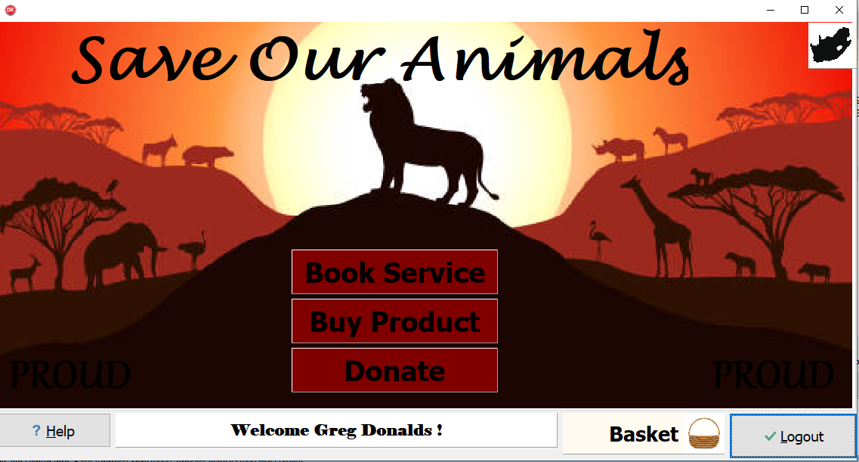

#### TbsProducts

A specific product is chosen and the amount of the desired product.

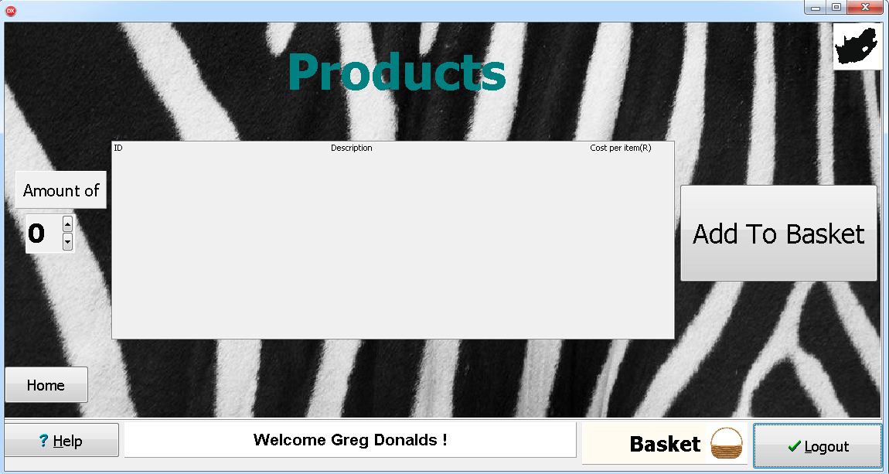

#### TbsService

A specific service is chosen and the amount of tickets, date, and time is selected.

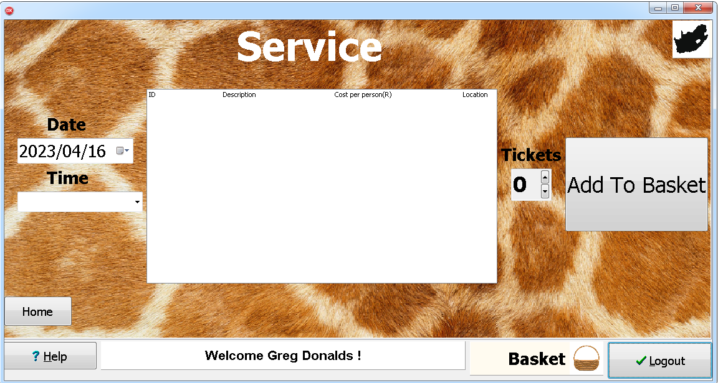

#### TbsBasket

All products and services purchased are shown and they can be increased removed or decreased. Items will be shown.

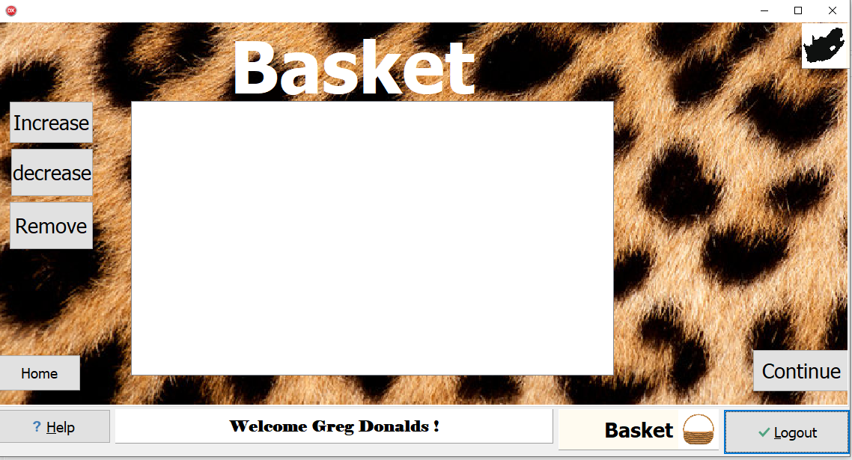

#### tbsDonate

Money donated from a % from the purchase or direct donation is shown and done here. Client chooses 3 Animals to whom direct donation or percentage of purchase should go.

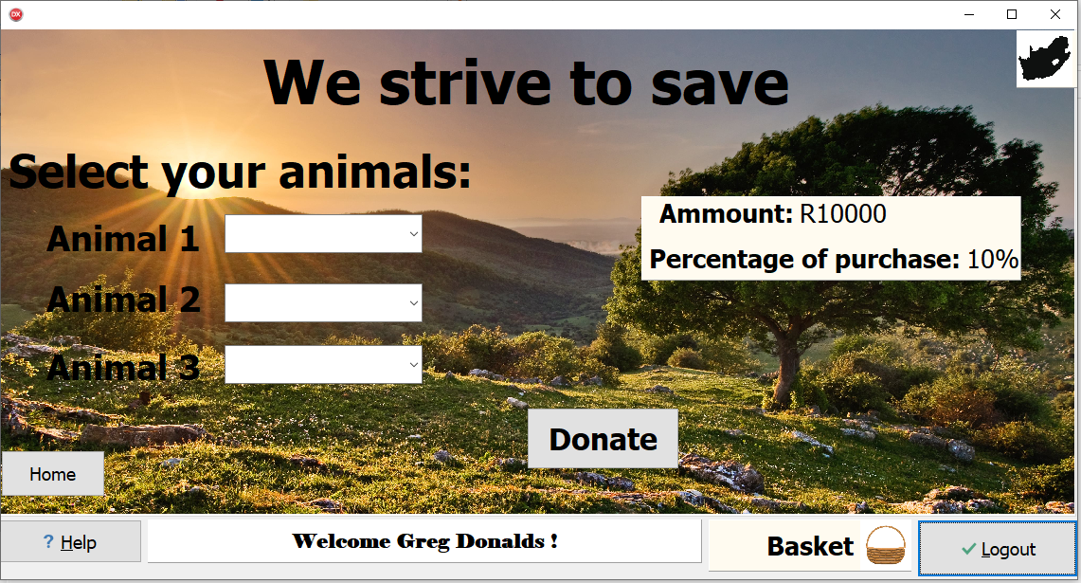

#### Help button

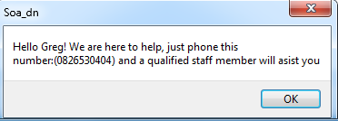

Components

type

TfrmUser = class(TForm)

bmbLogout: TBitBtn;

bmbHelp: TBitBtn;

PageControlUser: TPageControl;

tbsUser: TTabSheet;

tbsProducts: TTabSheet;

tbsService: TTabSheet;

tbsBasket: TTabSheet;

lblHomeU: TLabel;

btnHome1U: TButton;

btnHome3U: TButton;

btnHome2U: TButton;

pnlNameNum: TPanel;

sedAmount: TSpinEdit;

lstProducts: TListBox;

btnAddtoB: TButton;

cmbTime: TComboBox;

lstService: TListBox;

lstBasket: TListBox;

Label1: TLabel;

btnIncrease: TButton;

btnDecrease: TButton;

btnRemove: TButton;

btnContinue: TButton;

tbsDonate: TTabSheet;

Label2: TLabel;

cmbA1: TComboBox;

Label10: TLabel;

Label3: TLabel;

cmbA2: TComboBox;

cmbA3: TComboBox;

btnDonate: TButton;

Label7: TLabel;

Label8: TLabel;

dtpService: TDateTimePicker;

pnlDonate: TPanel;

Label11: TLabel;

pnlAmmountof: TPanel;

sedPersons: TSpinEdit;

btnAddtoBS: TButton;

Label13: TLabel;

Label14: TLabel;

Button8: TButton;

imgNature: TImage;

pnlPercP: TPanel;

Label15: TLabel;

Label16: TLabel;

Label17: TLabel;

Label18: TLabel;

imgCheetah: TImage;

imgGiraffe: TImage;

imgZebra: TImage;

pnlBasket: TPanel;

Label4: TLabel;

imgBasket: TImage;

pnlSouthAfrica: TPanel;

imgSA: TImage;

imgAnimals: TImage;

Label9: TLabel;

Label6: TLabel;

pnlProducts: TPanel;

pnlServices: TPanel;

Label5: TLabel;

# IPO tables

Blue Fill = Processes/Algorithms

Maroon Text inside Blue Fill = Description of process

Green Fill = validation

Red Text = Error message

Orange Text = Output

### Input, Processing Validation Output

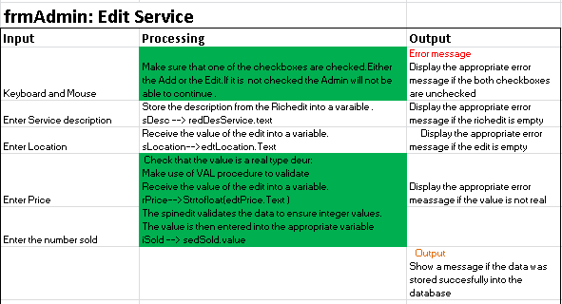

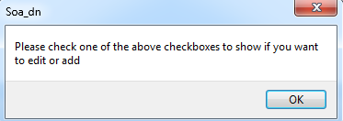

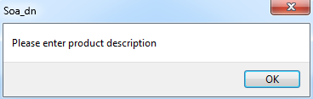

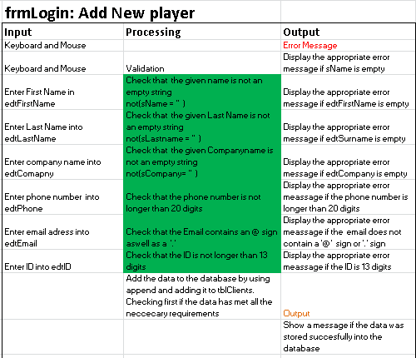

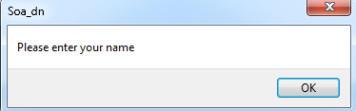

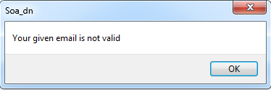

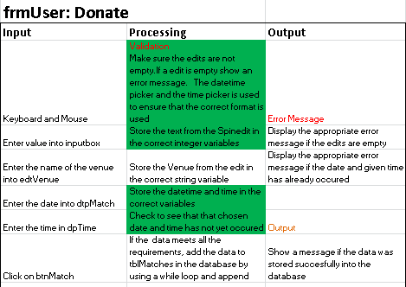

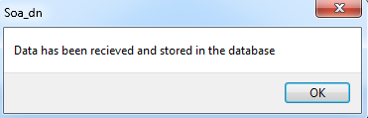

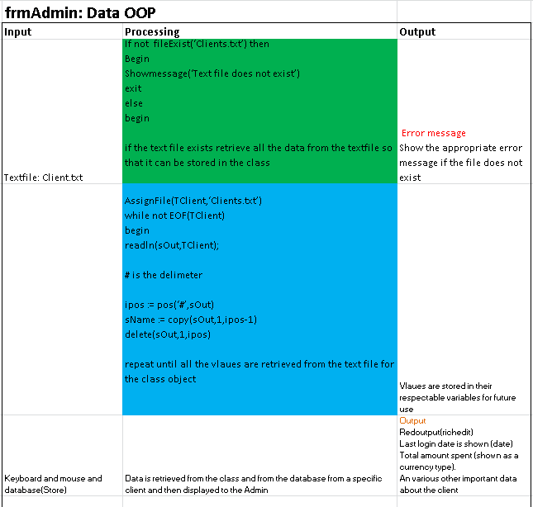

Output

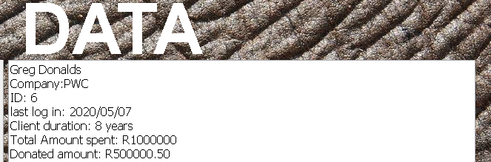

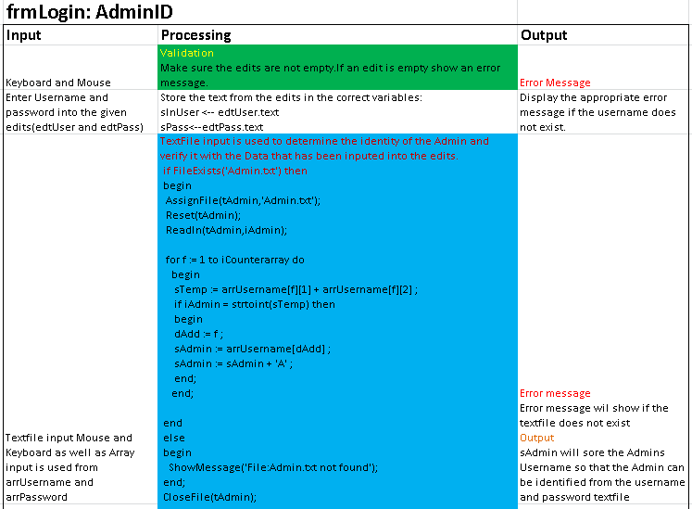

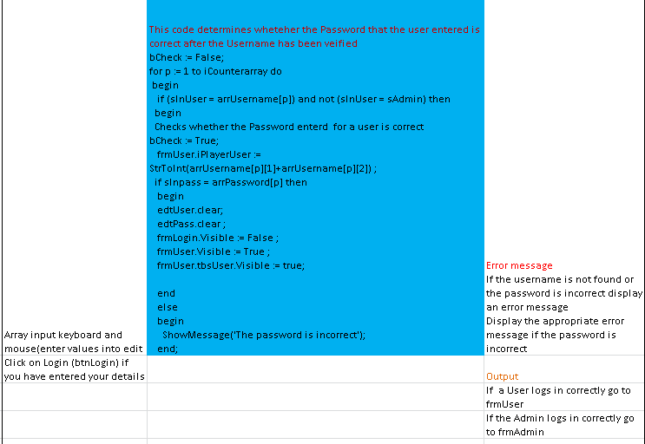

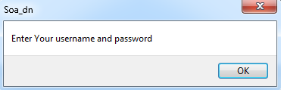

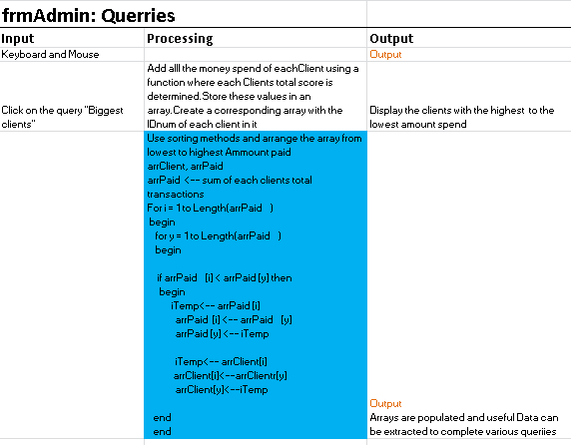

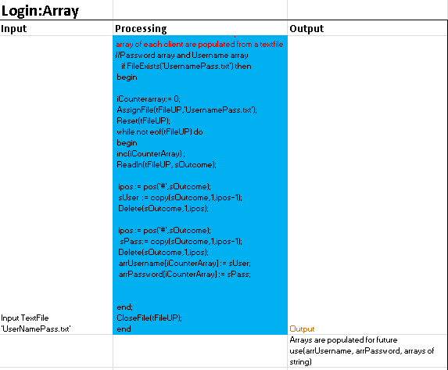

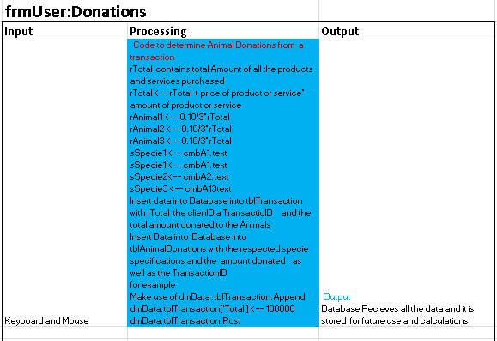



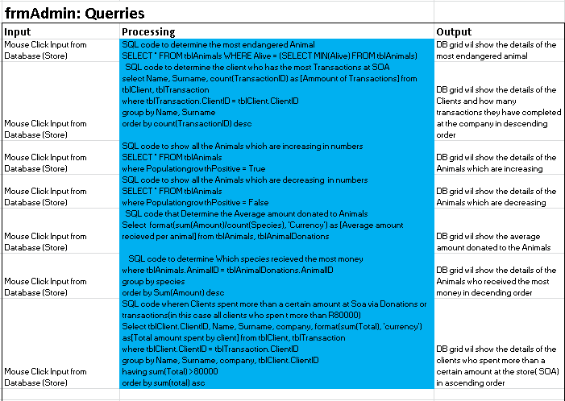

Output:DBGRID

